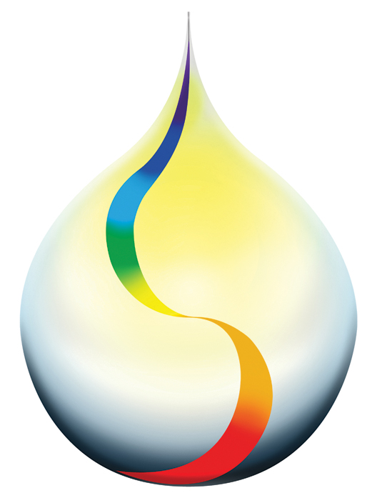

Holistic Wellness Centre

Touch for Health Kinesiology Courses

The Holistic Wellness Centre offers Touch for Health (TFH) courses for anyone who is interested in learning how to use kinesiology in their life to achieve a life of wellbeing and vitality. We offer the individual TFH modules as TFH 1- 4 or as a Certificate in Touch For Health Synthesis that encompasses all 4 levels.

Certificate in Touch For Health Synthesis is accredited with the International Kinesiology College (IKC) and endorsed in over 60 countries worldwide. It is the most widely recognised of all kinesiology modalities and serves as foundation and grass roots training to professional and practitioner training in kinesiology.

What is Touch For Health Kinesiology?
- It is a system of natural health care which combines muscle monitoring with the principles of Chinese medicine to assess energy and body function, applying a range of gentle, yet powerful healing techniques to improve health, wellbeing and vitality.
- It addresses the structural, nutritional and emotional stresses common in everyday life.
- Touch for Health techniques involves skills researched from modern chiropractic, naturopathy, osteopathy and ancient Chinese acupuncture.
- It uses the muscles in the body as a bio‐feedback mechanism.
- It is a great tool that works at the connection between mind and body, using the electromagnetic energy system called meridians, which are the interface between the physical and subtle energy bodies. Raising energy through the acupuncture meridian system allows the person to feel positive health benefits, encouraging the natural processes of the body to enhance health and vitality.

You will receive a certificate at the completion of each TFH level or a Certificate in Touch For Health Synthesis on completion of TFH 1 – 4. These certificates are issued by the IKC and are recognised by the Australian Kinesiology Association (AKA) and the Australian Institute of Kinesiologists (AIK). You may use your completed hours towards becoming an accredited member or as professional development hours as a natural therapist.

All the Touch For Health courses are taught by a Registered TFH Instructor. The Australian Kinesiology Association and the Australian Institute of Kinesiologists approve and award each TFH level 16 hours Category A accreditation. The TFH Synthesis will be awarded 64 hours Category A accreditation.

Touch For Health 1
This introductory course developed by Dr John Thie in the 1970’s, introduces you to the ‘grass roots’ of kinesiology. Touch for Health has been taught to over 10 million people worldwide, in over 100 countries and translated in some 26 languages.

You will learn:
- Core techniques of muscle testing for the primary 14 energy meridians based on Traditional Chinese Medicine
- To perform the standard 'fix-‐as-‐you-‐go' techniques for balancing the whole body's energies.
- About the acupuncture meridians and powerful reflex techniques that are used to restore balance for dramatically improving posture, alleviating pain and stress, and for enhancing vitality and mental performance.

Prerequisites: None

Touch For Health 2
This course follows on from TFH 1 as you will be introduced to additional muscle tests and more detailed kinesiology balancing techniques and theory.

You will learn:
- About Circuit Locating which helps identify the body's priority balancing process.
- How to use alarm points to detect over-‐energy in the body
- To use Meridian Wheel and the Chinese Law of Five Elements
- Brain Integration with Cross Crawl
- Testing for possible food sensitivities and for foods or supplements that raise your body’s energy.
- Simple techniques to relieve pain and stress and, to improve physical, mental and emotional performance.

Prerequisites: Touch For Health Level 1

Touch For Health 3

This is the third level of the Touch for Health Synthesis.

You will learn:
- Another 14 muscle tests and enhance your knowledge of the human body. Additional techniques for balancing the whole body's energy.
- Techniques for dealing past trauma
- To have a deeper understanding of the Five Elements theory.
- Pulse assessment and pain tapping for chronic pain.
- Reactivity within muscles
Prerequisites: Touch For Health Level 2

Touch For Health 4
This level completes your training in the Touch for Health Synthesis.

You will learn:
- To balance all 42 TFH muscles in a standing or prone position and apply the Five Elements to release emotional issues in order to experience a more holistic approach to healing.
- About sound balancing, Luo Points, Postural Stress Release, Tibetan Figure Eight Energies, Acupressure Holding Point theory
- To 'put it all together' with a specific goal for optimal wellness in the whole body.

Prerequisites: Touch For Health Level 3

